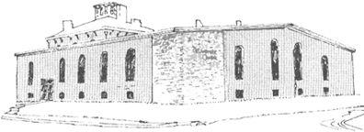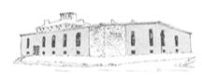

****

Pastor James Reynolds, Sr.

Asst. Pastor Stephen G. Reynolds, Sr.

1008 Congress St. Portland, ME 04102

Tel. (207) 774-8192

[www.**thedeliverancecenter**.com](http://www.thedeliverancecenter.com)

*From the Desk of Pastor Stephen Reynolds, Sr.*

Sir, Mark Mclain

Philippians 4:4—*Rejoice in the Lord alway: and again I say, Rejoice.*

Psalm 150:6—*Let everything that hath breath praise the LORD. Praise ye the LORD.*

Where is Salvation taking you?

Ex. 14:13 And Moses said unto the people, Fear ye not, stand still, and see the salvation of the LORD, which he will shew to you today: for the Egyptians whom ye have seen to day, ye shall see them again no more for ever.

The Salvation of the Lord brought Israel through the Red Sea.

The Salvation of the Lord will bring you through any and every trial if you are willing to trust in Christ.

Is Salvation taking you to Honor the Lord in this Fashion?

Rev. 19:1—*And after these things I heard a great voice of much people in heaven, saying, Alleluia; Salvation, and glory, and honour, and power, unto the Lord our God:*

If you let it, It will make you just like Jesus.

Missing the Red Sea crossing for Israel would have been deadly, missing prayer and devotion this morning on chastisement of the Lord Job 5:17 and the Arrows of the Almighty Job 6:4 is serious.

Doing a chore for correction is a very small thing compared to what could happen, no one can miss prayer for any reason, it is absolutely necessary for your life plus your schooling.

CHORE--- PRAY IN THE CHURCH FROM !:00 P.M.to 2:00 P.M.

Sincerely,

Stephen G. Reynolds, Sr.

Assistant Pastor